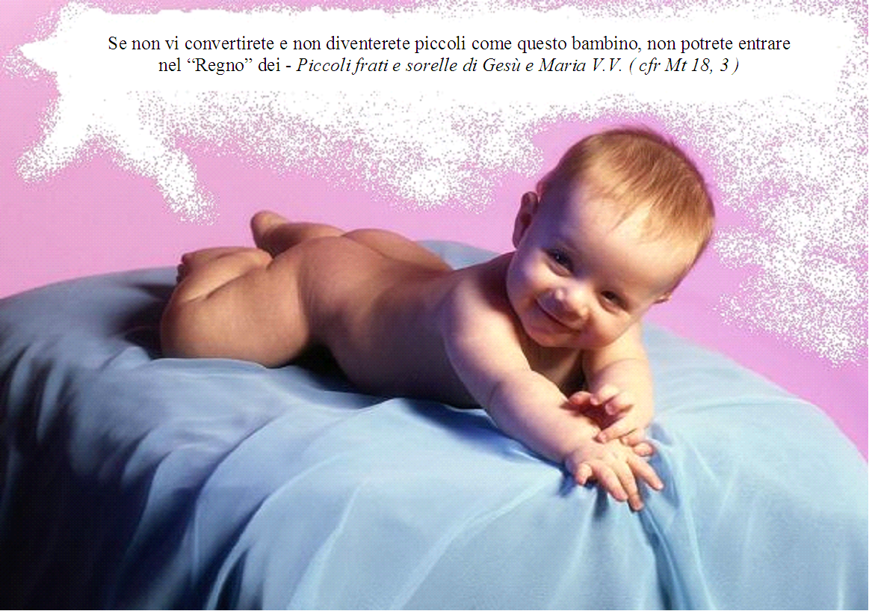
Unless you convert and become little like this Baby, you will not be able to enter into the
“Kingdom” of – Little friars and sisters of Jesus and Mary V.V. ( Cf. Mt 18, 3 )

